Name: Mriganka Patra
Email – mriganka.patra@cognizant.com
Emp id - 2415820

Assignment 2: Object Manager, App Builder, and Page Customization
Objective:
Learn to navigate Salesforce CRM by working with Object Manager, customizing apps and interfaces using the Lighting APP Builder:
Tasks:
- Log into a Salesforce Developer Account
- Navigate to Object Manager and Create Custom Object named ‘ Project’
- Add at least 5 custom fields (Ex: Project Name, Start Date, End Date, Status, Budget)
- Create a new tab for the ‘Project’ Object
- Customize the page layout to show only relevant fields and record sessions.
- Use Lighting App Builder to create a new app including the ‘project” object and assign it to a profile
- Create two different Record Types for ‘Project’: Internal and Client-based projects with different layouts
Deliverables:
- Screenshots or steps for creating custom object, tab and layouts
- Summary of record types and configuration

Task 1: Log into a Salesforce Developer Account

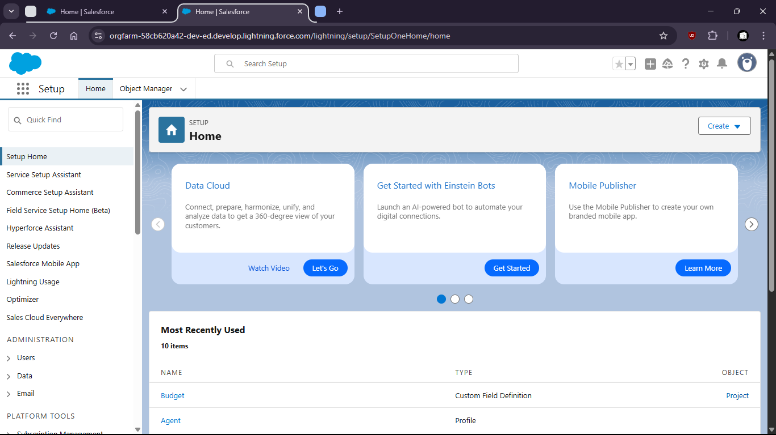

Task 2 : Navigate to Object Manager and Create Custom Object named ‘ Project’

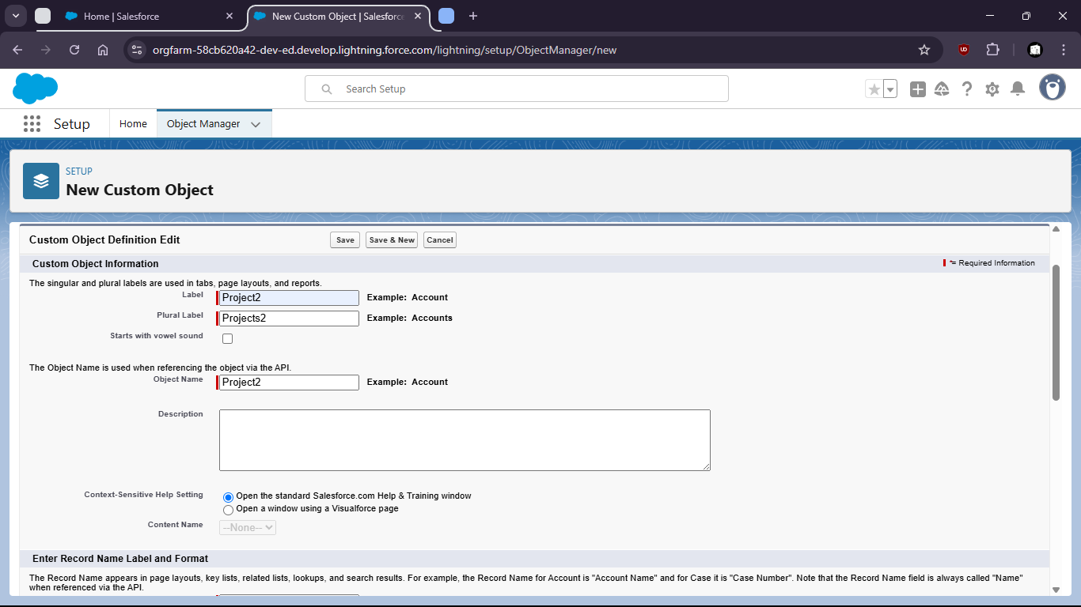

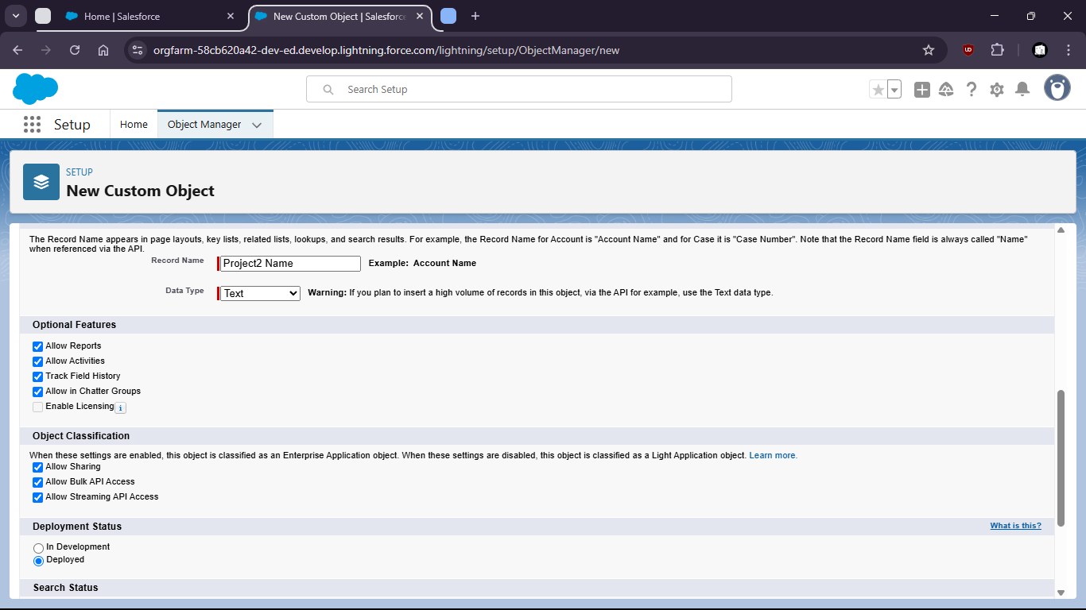

Task 4 : Create a new tab for the ‘Project’ Object
Go to tabs and set visibility, etc

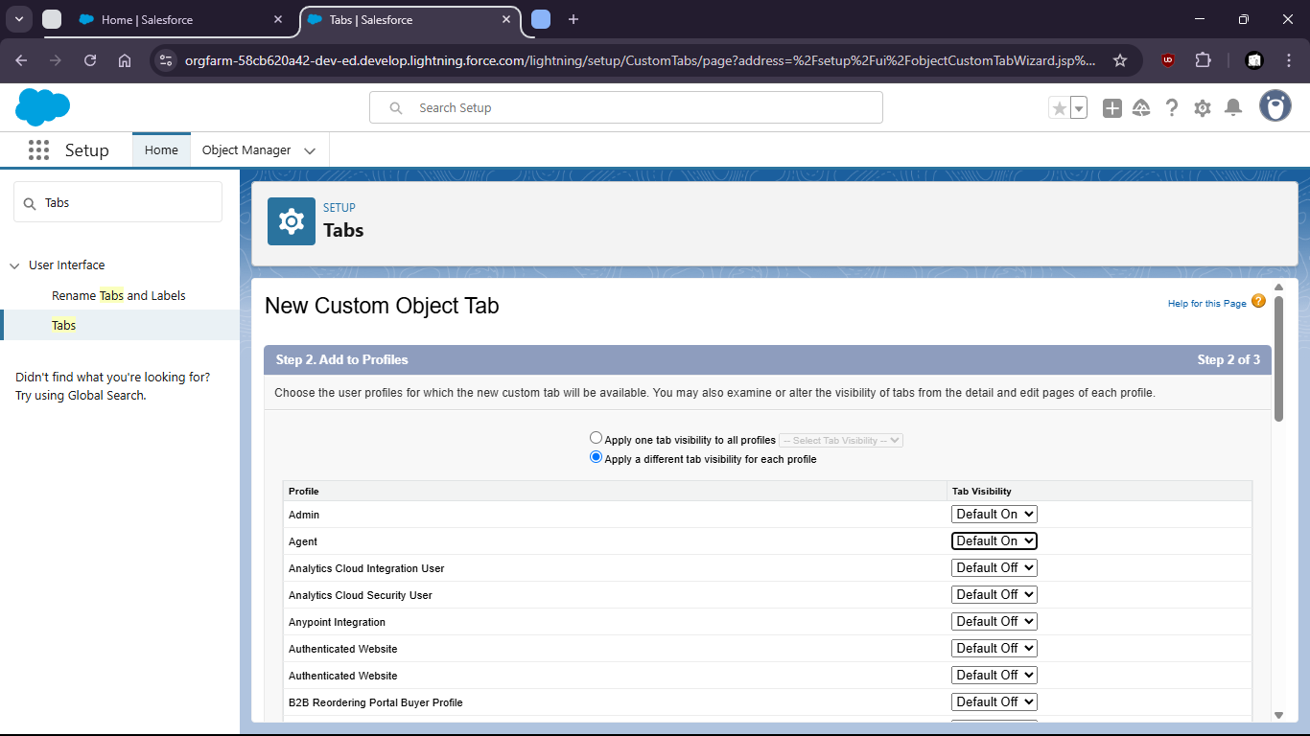

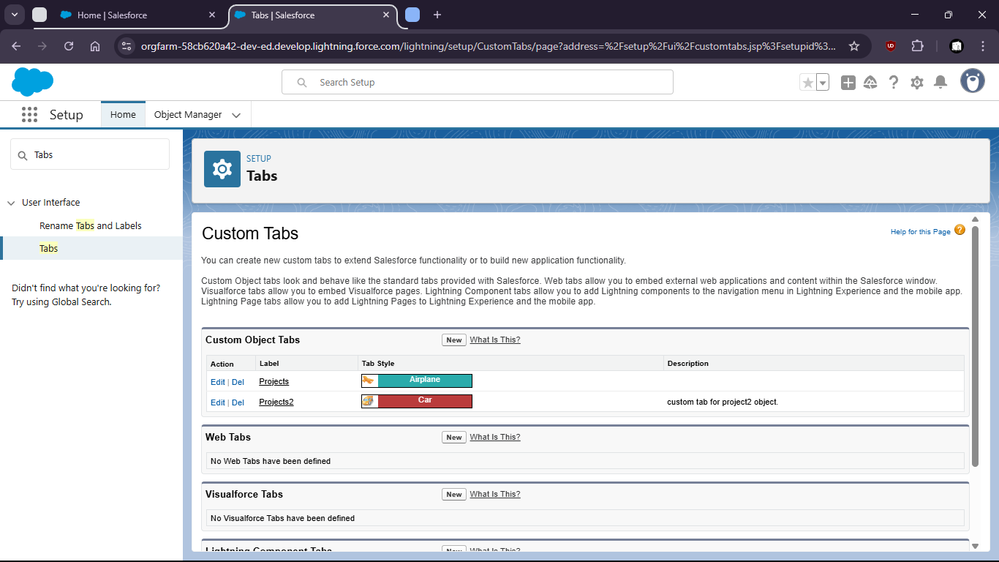

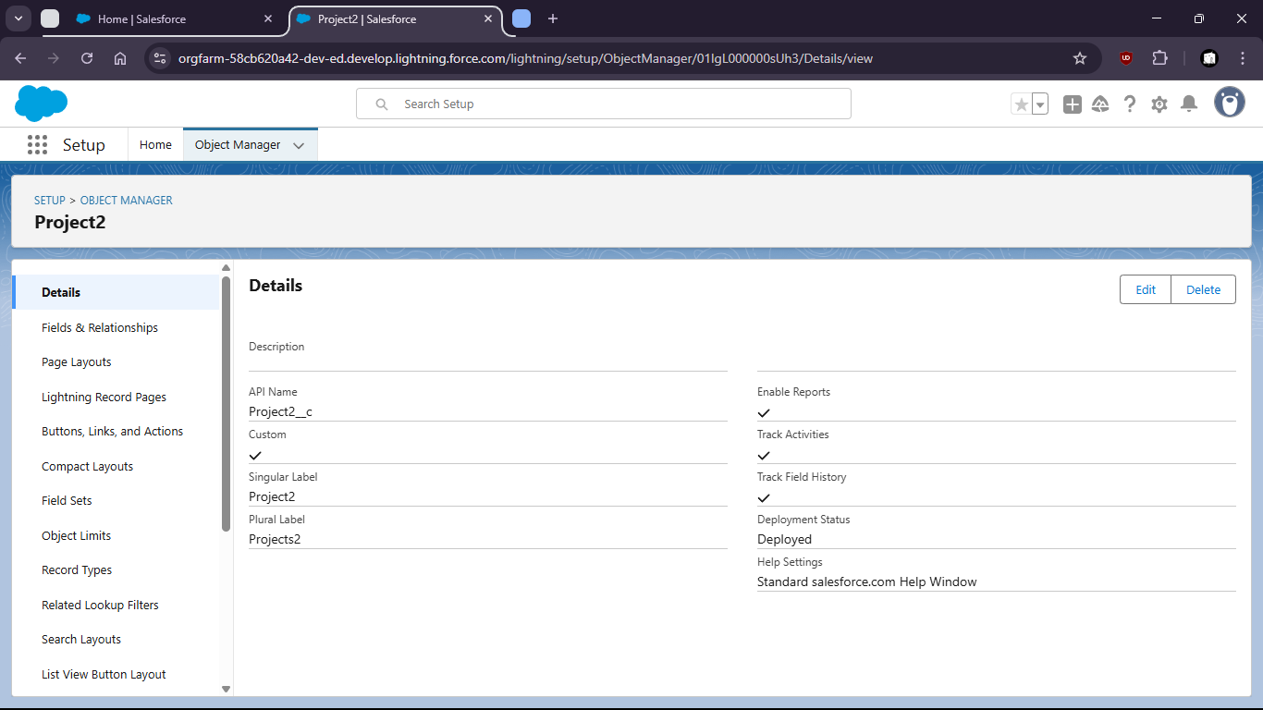

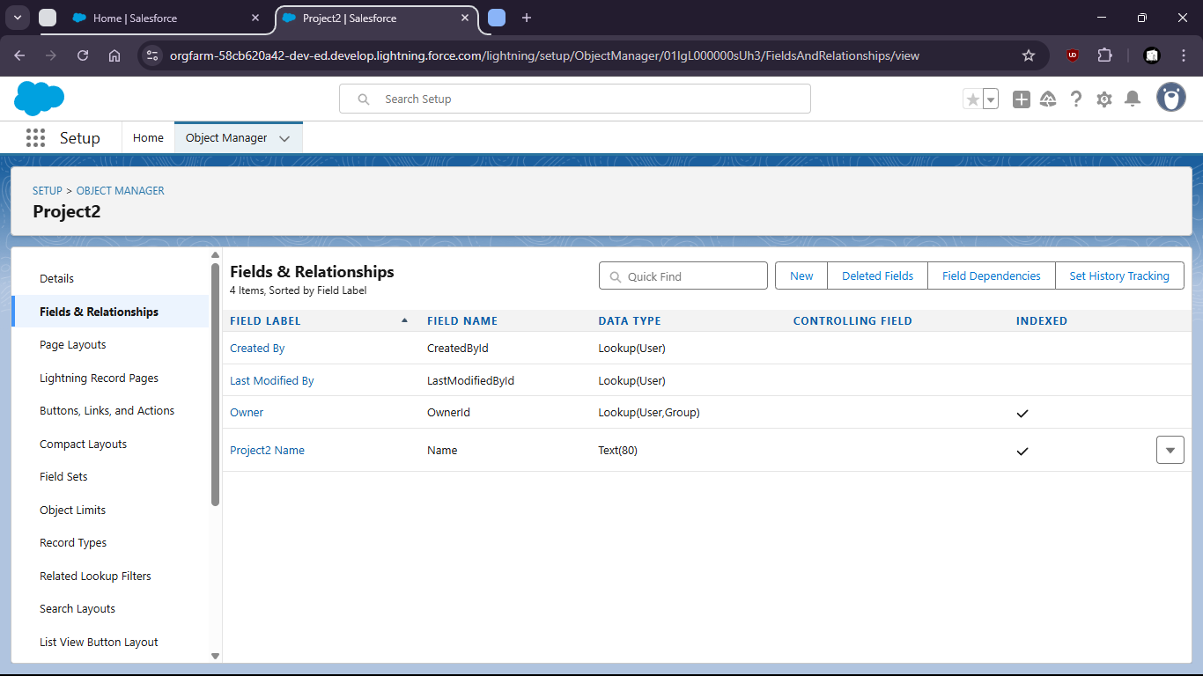

Task 3 : Add at least 5 custom fields (Ex: Project Name, Start Date, End Date, Status, Budget)

- Start date addition.

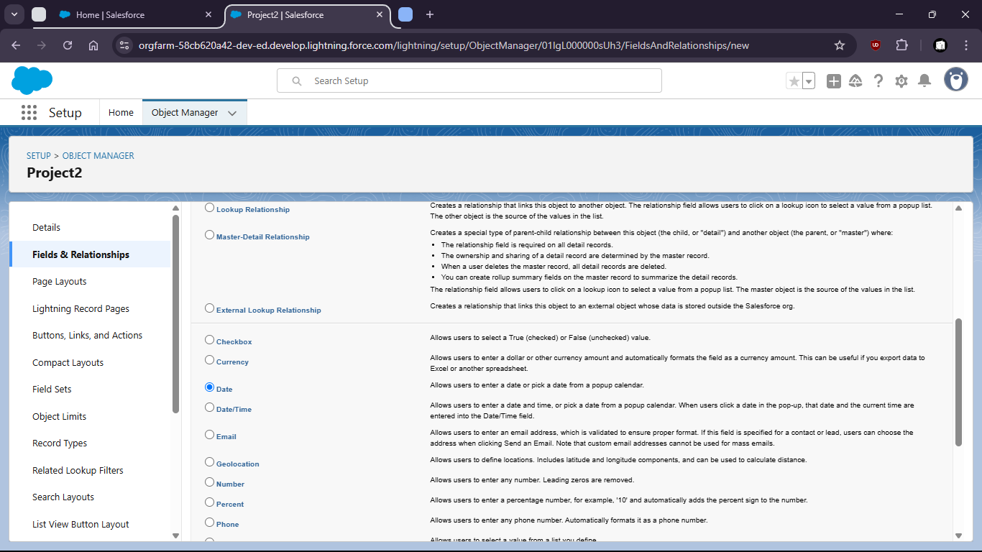

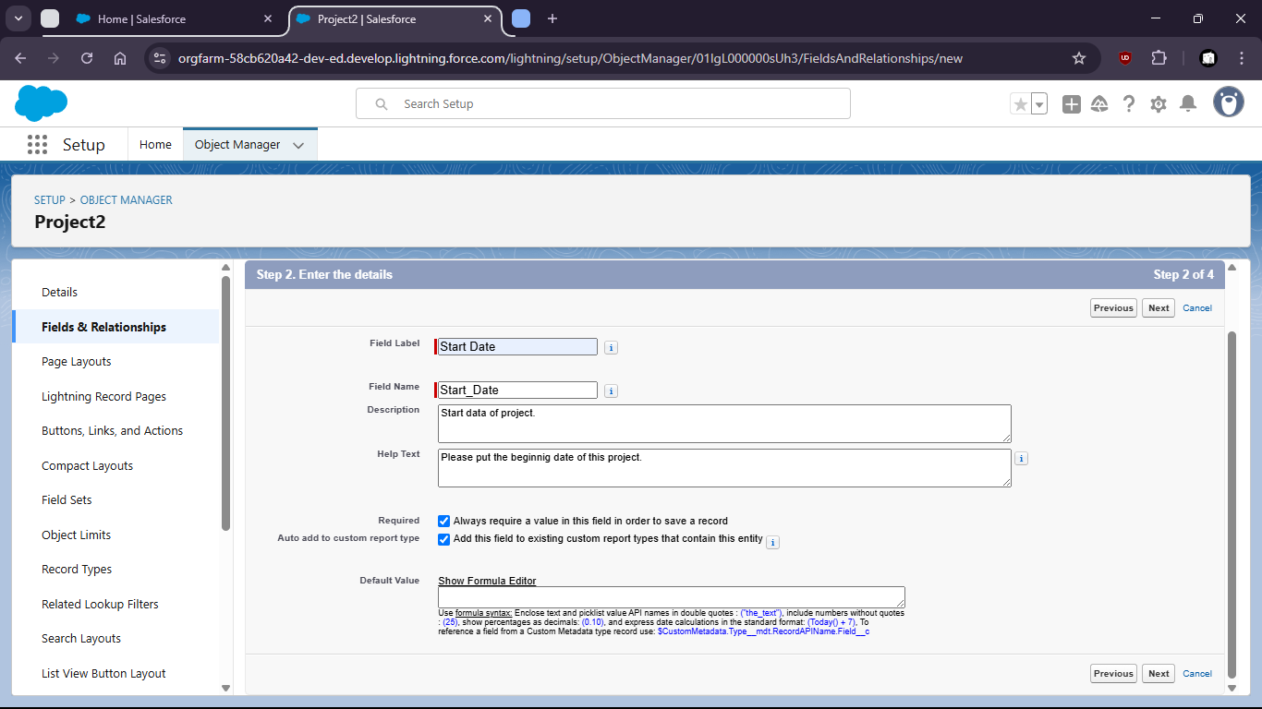

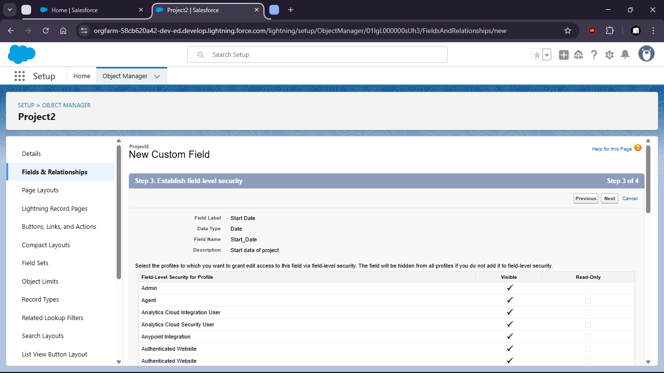

- Pick-list addition

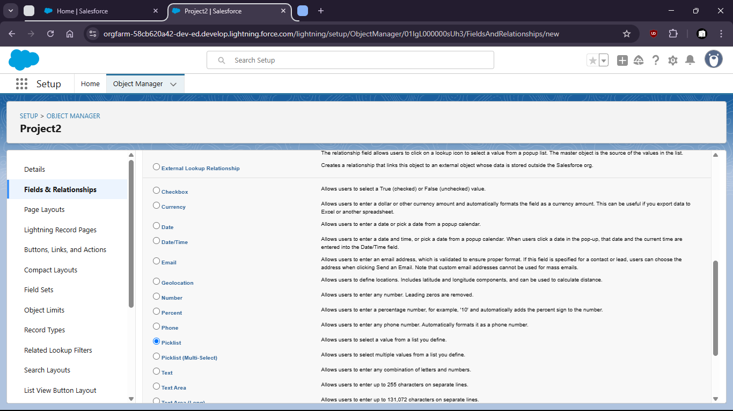

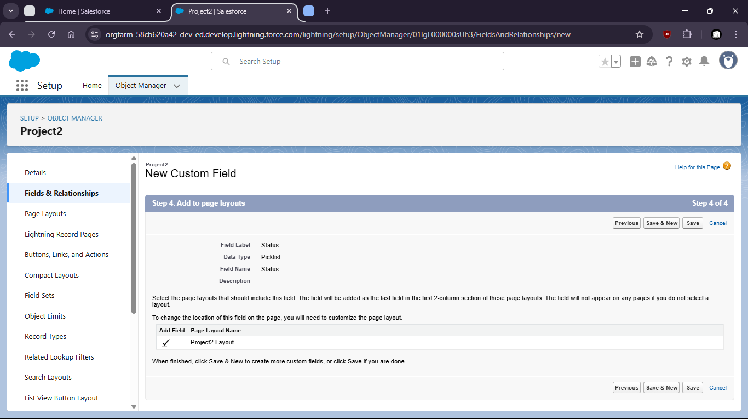

For Budget pick ‘Currency’

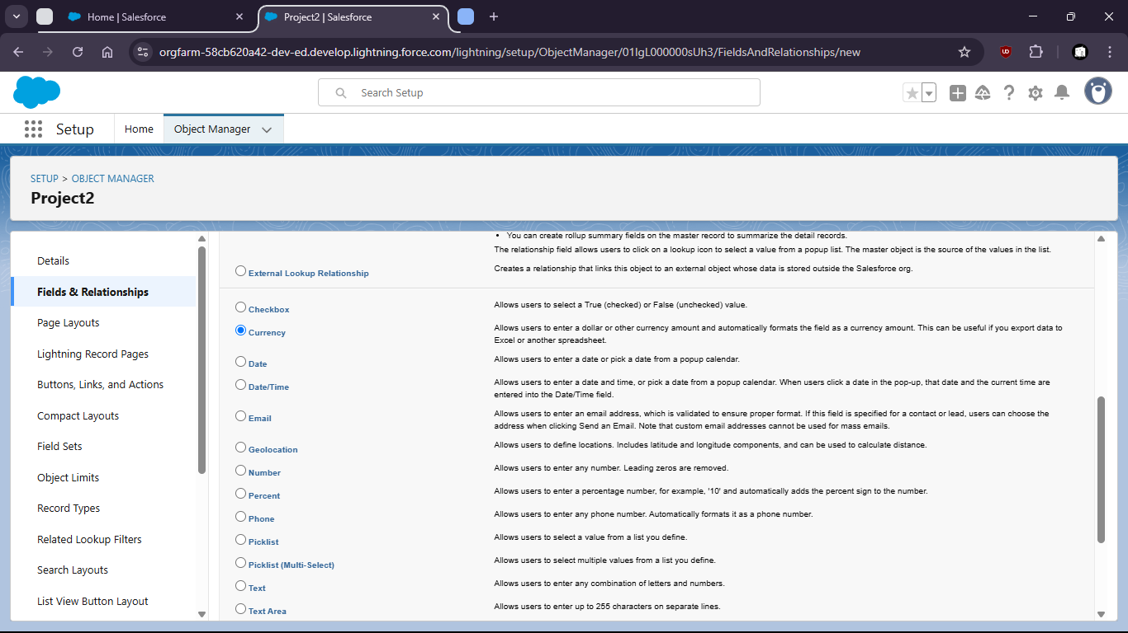

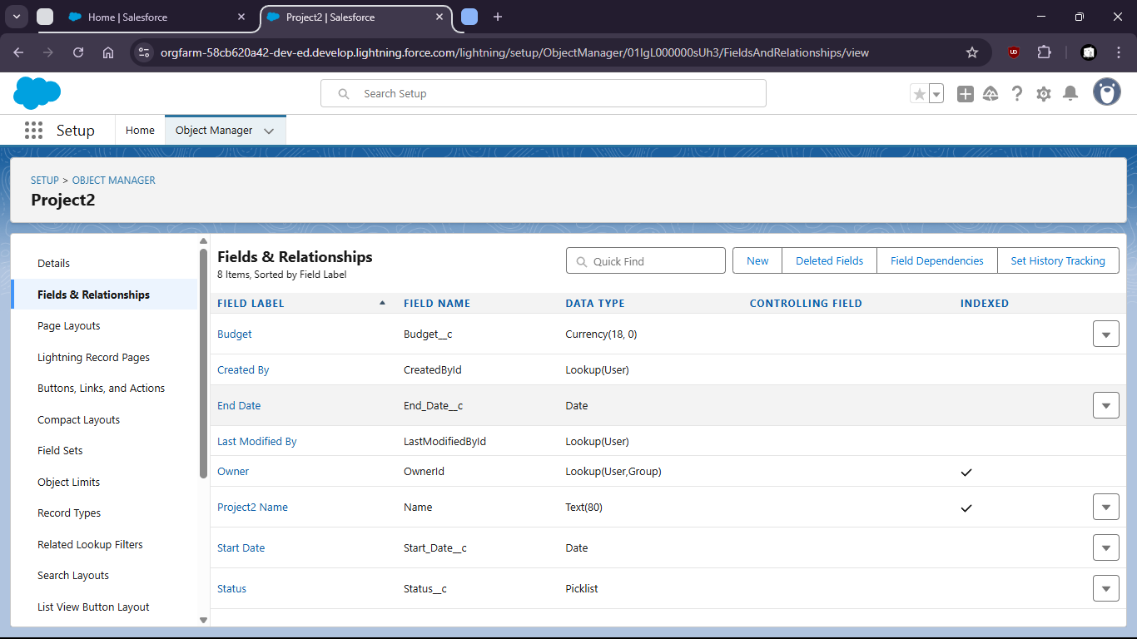

Task 5 : Customize the page layout to show only relevant fields and record sessions.

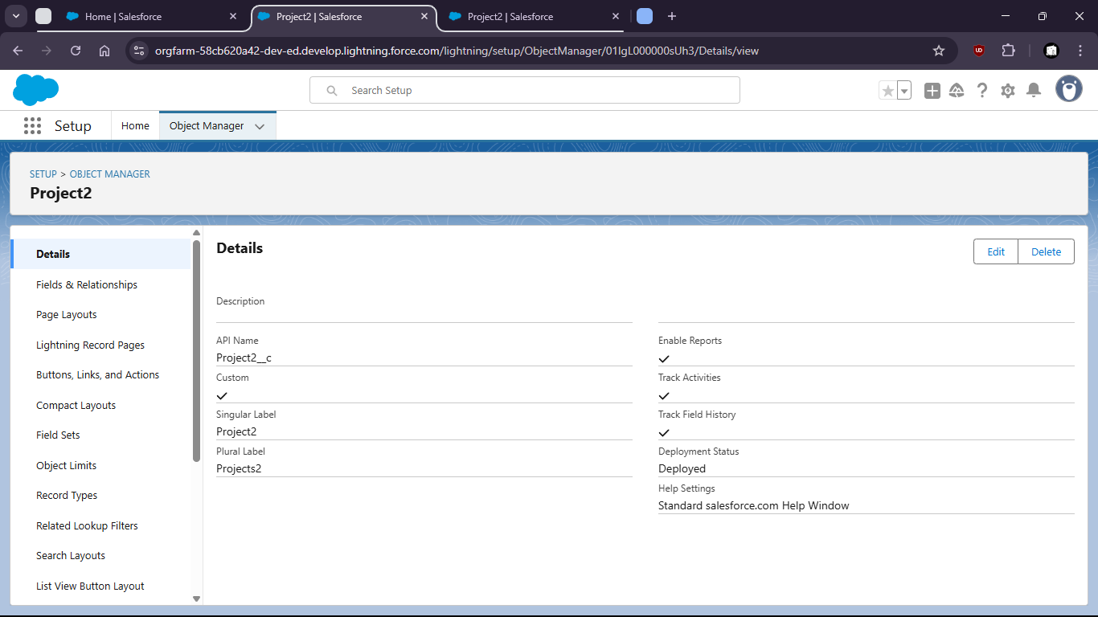

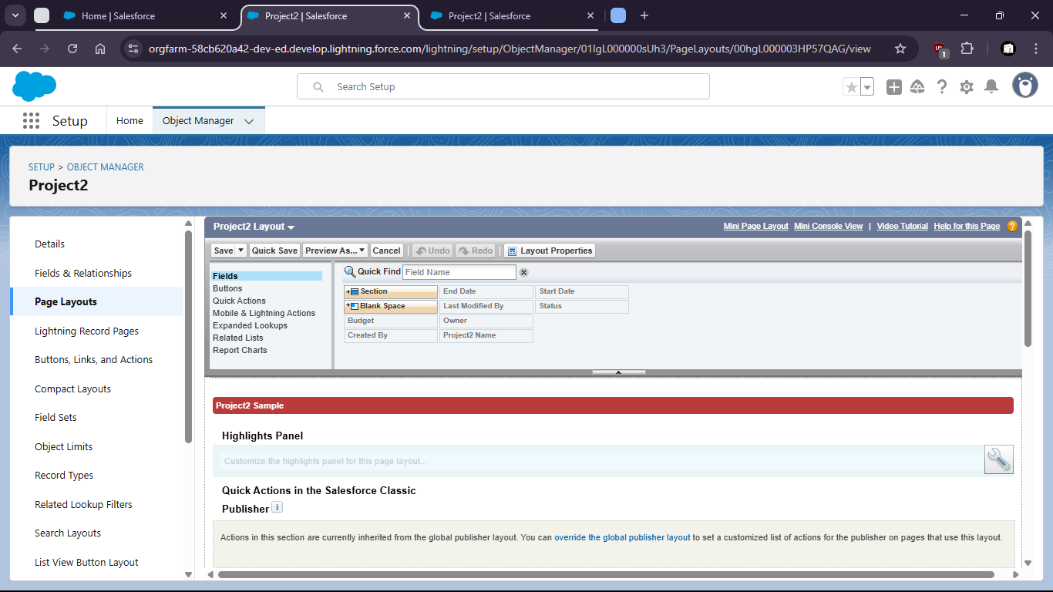

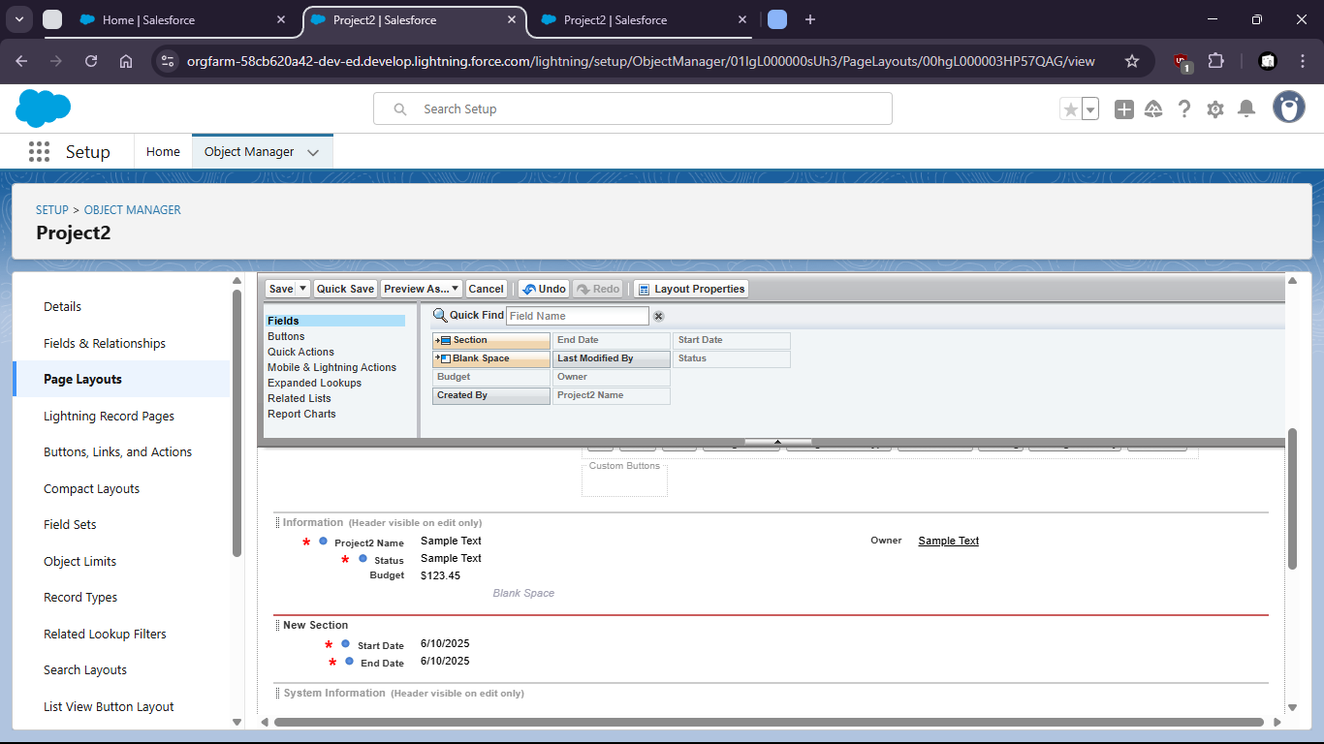

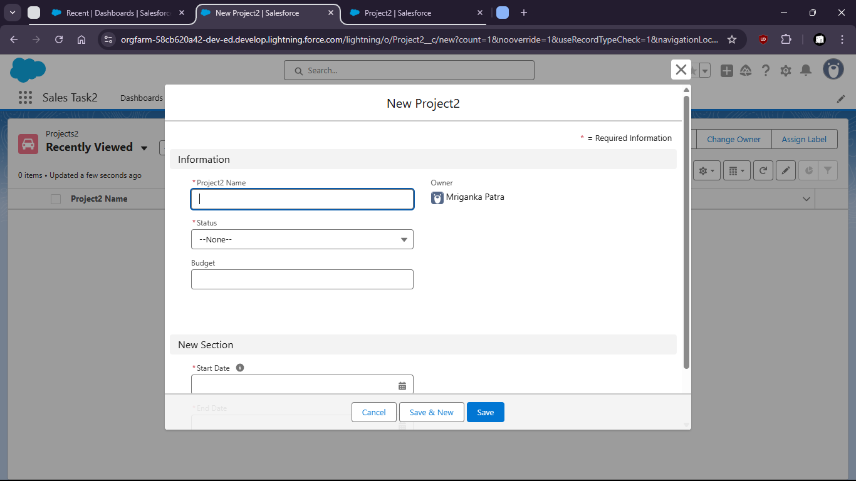

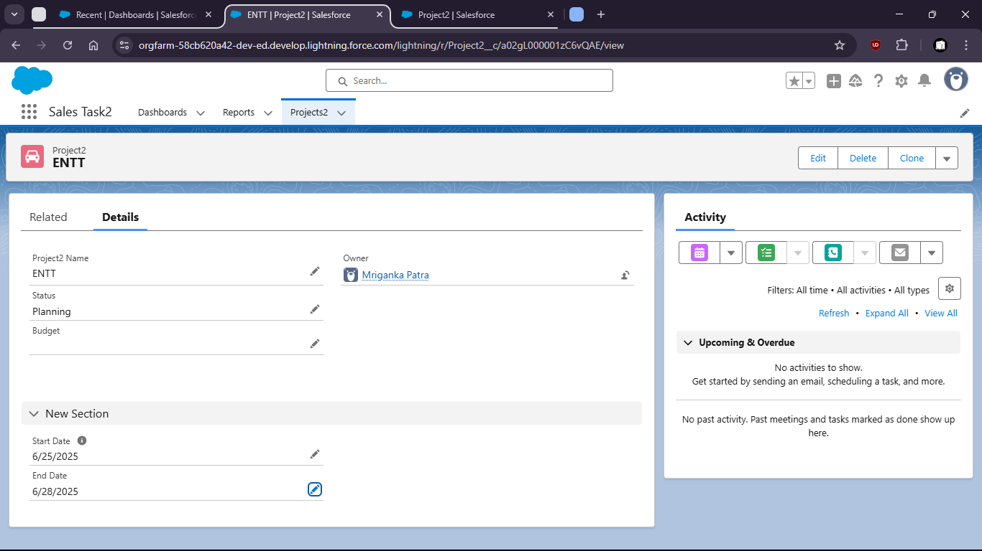

Task 6 : Use Lighting App Builder to create a new app including the ‘project” object and assign it to a profile

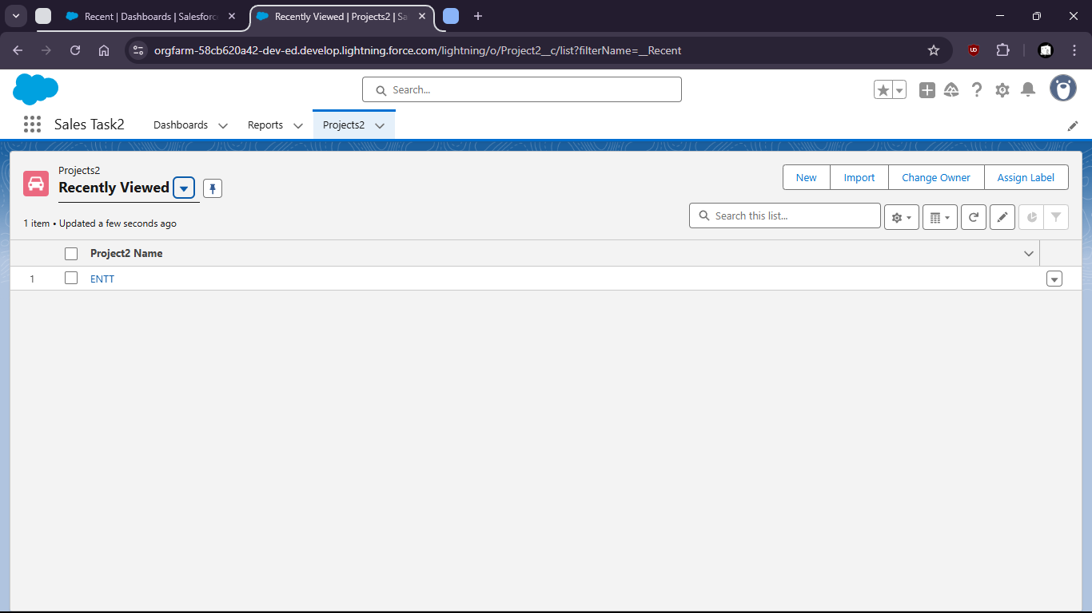

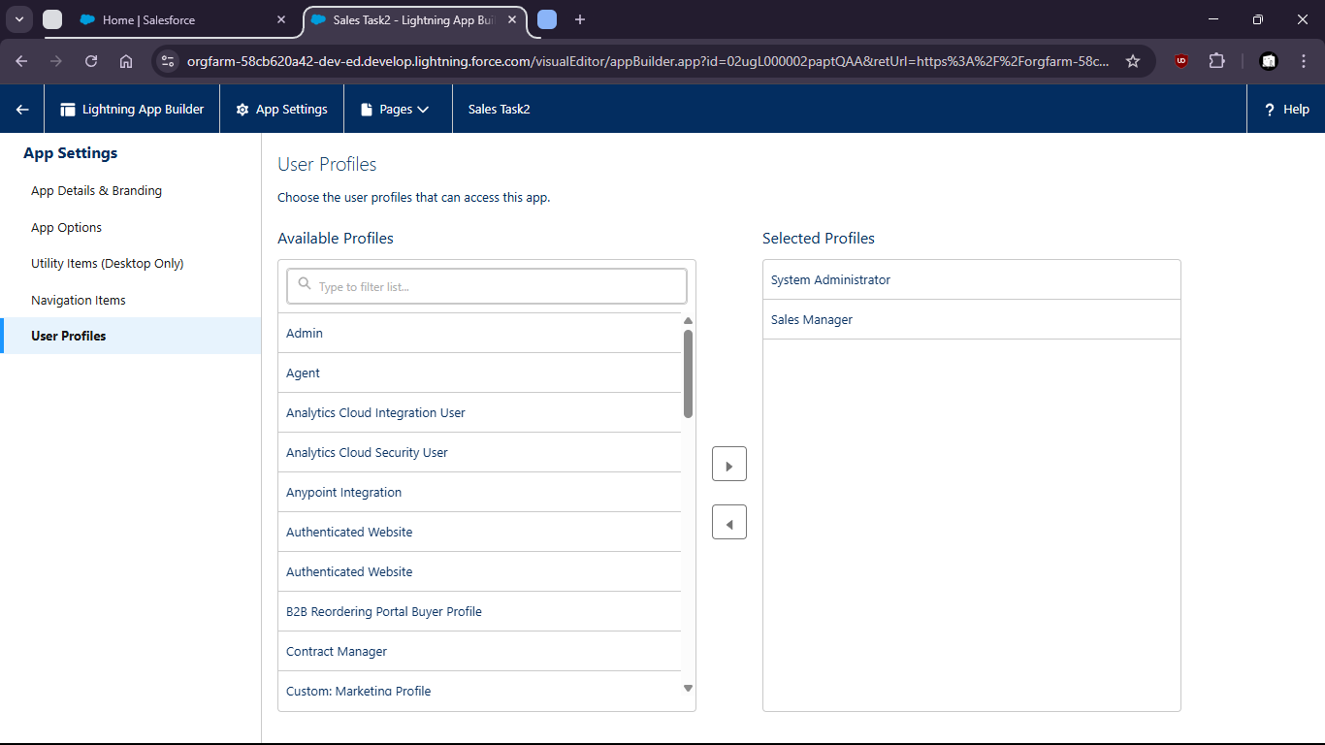

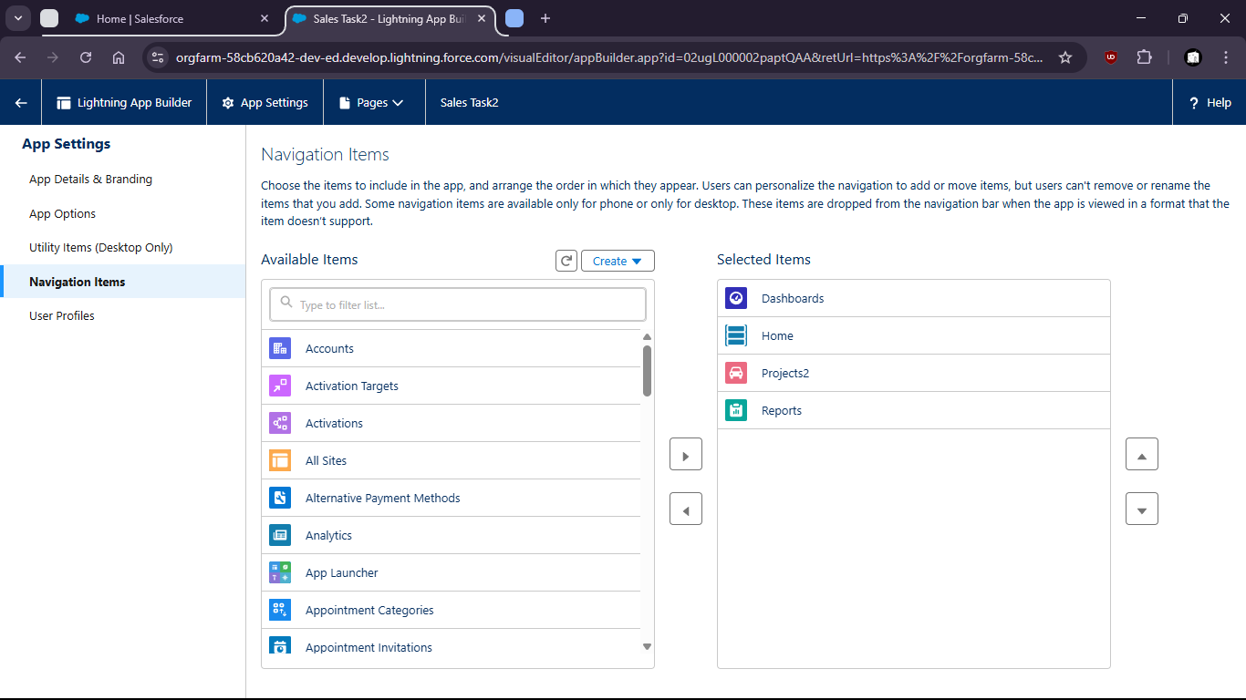

Task 7 : Create two different Record Types for ‘Project’: Internal and Client-based projects with different layouts

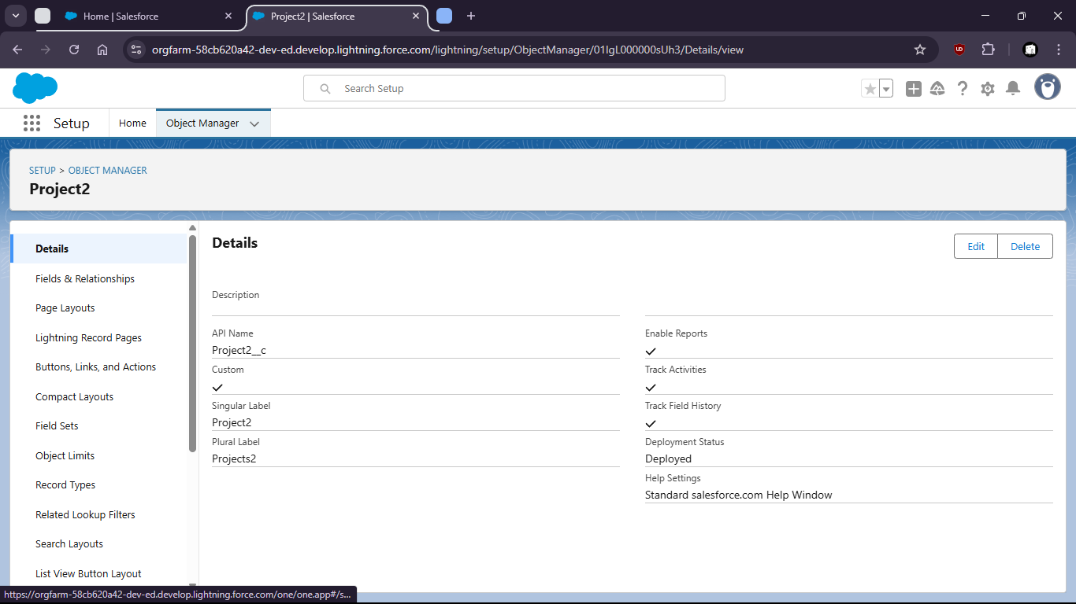

Internal Project Layout (for Projects2)

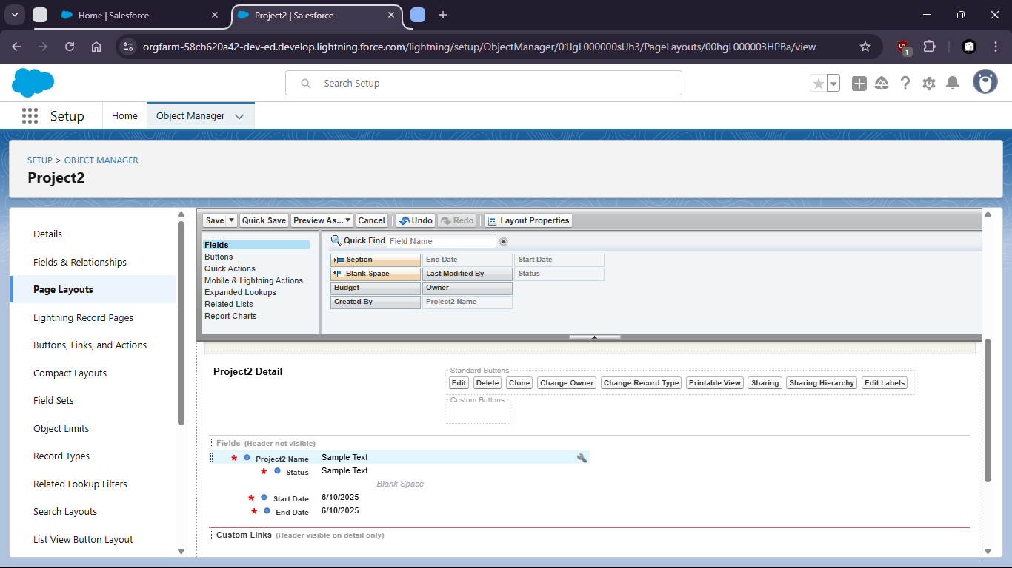

Client Project Layout

